Adding Evidence

We can add an evidence item very quickly. An investigator would need to select the “Add Evidence Item” **Icon** () by either selecting to either add one item or all the devices on a computer or by using **File button in Menu bar.**

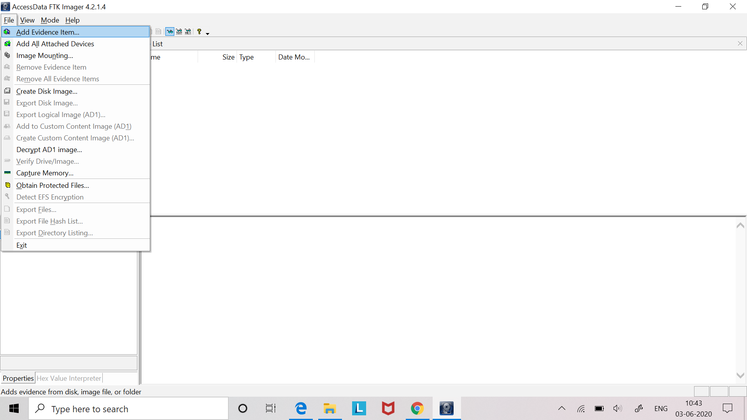

FTK Imager allows us to add four types of evidence sources for preview, that are Physical Drive, Logical Drive, Image File and Contents of a Folder. I’ll add all types of sources one by one.

Adding a physical drive will add the entire contents of a physical drive, to include all partitions associated with that device. Adding a logical source will only load the contents of a logical drive including unallocated space. When you add an image file, this will load the image file as it was created, either Raw (dd), SMART (S01), E01 or AFF. Lastly, we can add an individual folder for an analysis.

**Adding Physical Drive**

After selecting the type of evidence as “Physical Drive”, it presents the “Source Drive Selection.” From here, we will see what devices are attached to our machine and an we can select what device best fits our investigation.

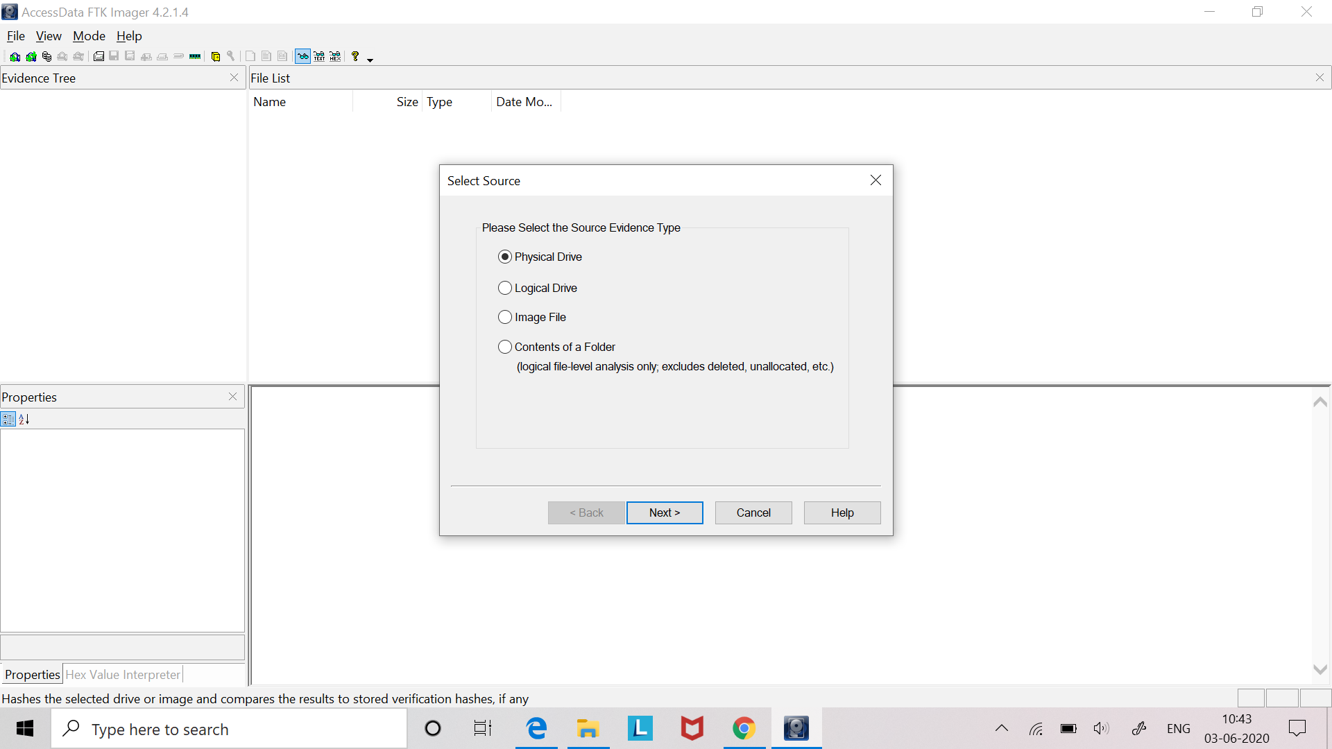 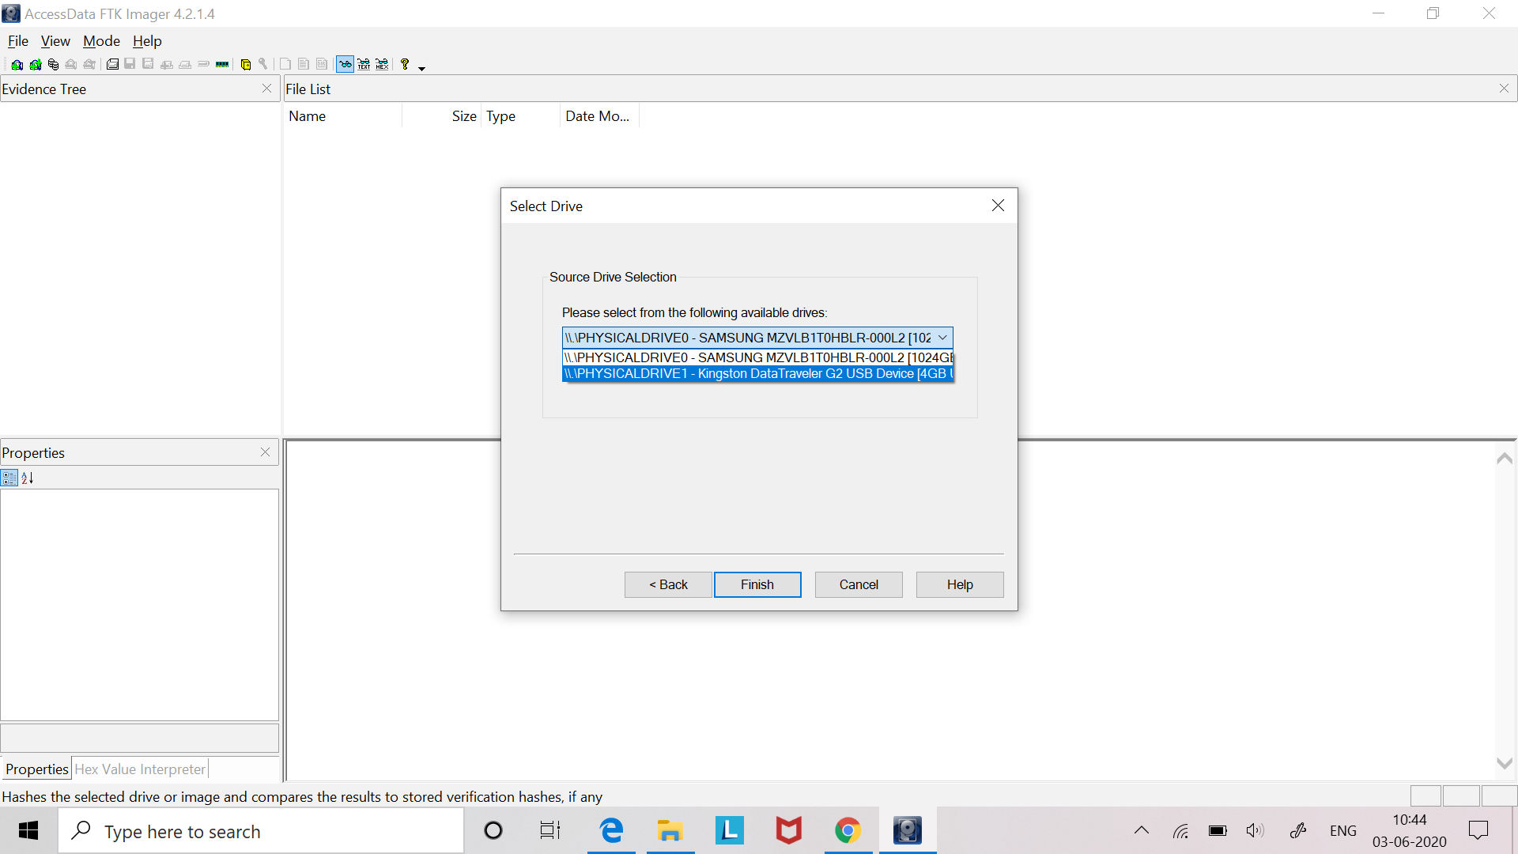

Successfully added the Physical drive.

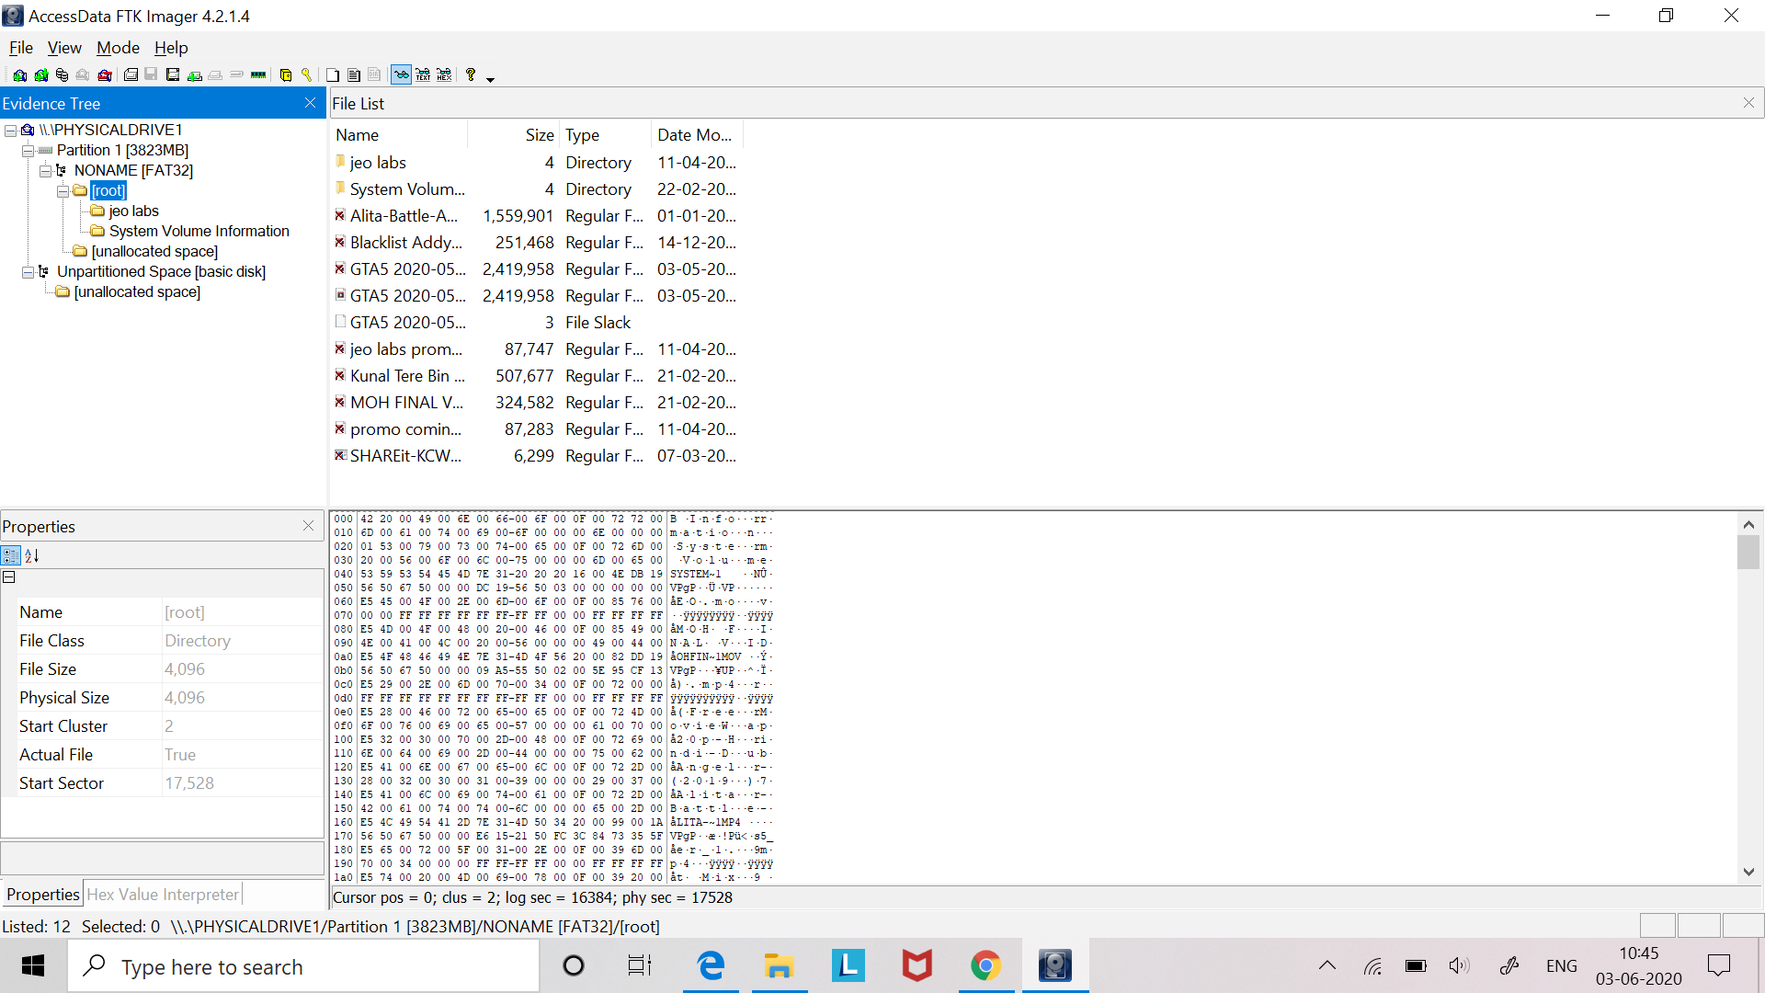

**Adding Logical Drive**

After selecting the type of evidence as “Logical Drive”, it presents the “Source Drive Selection.” From here, we will see what Logical drives that are present in the suspect’s system and than we can select what drive best fits our investigation.

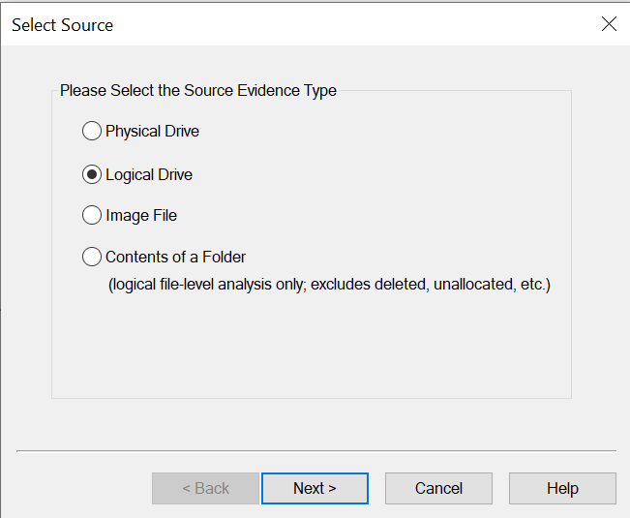 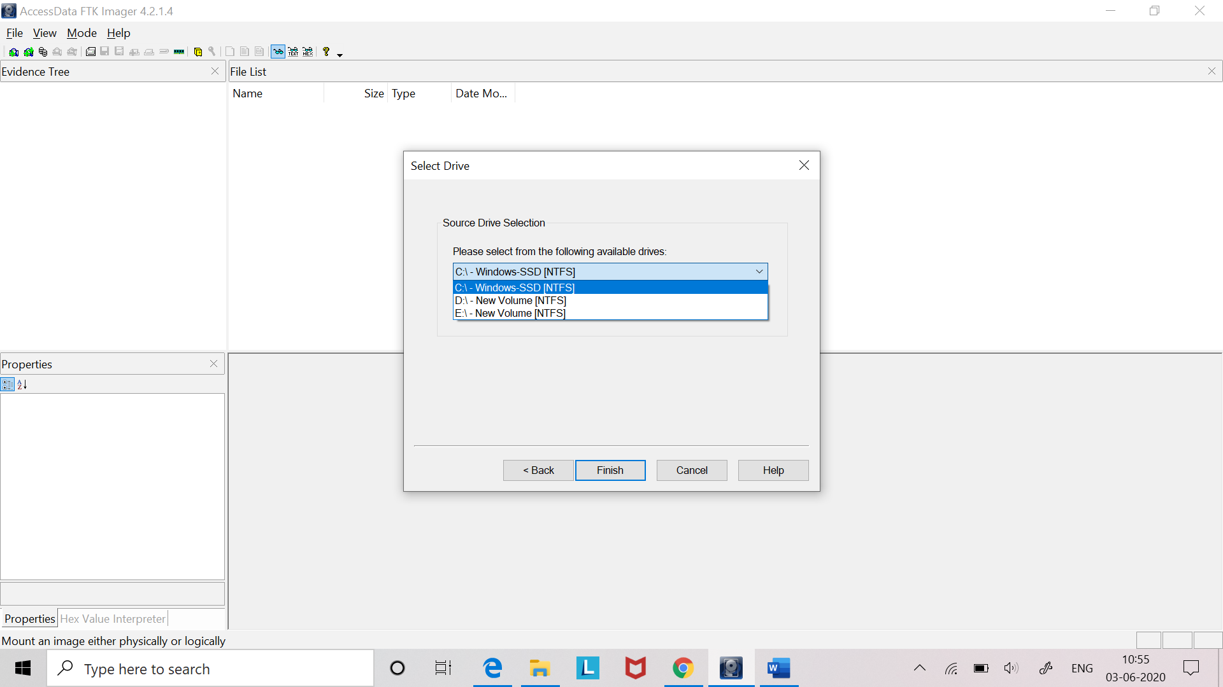

Successfully added Logical drive.

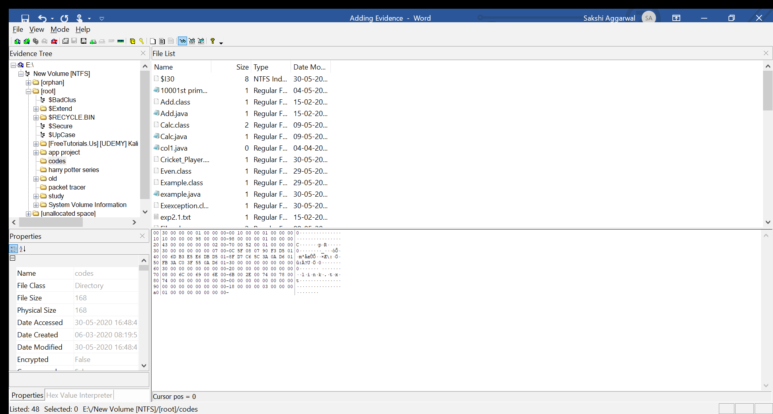

**Adding Image File**

We can load the already created images file to preview its data which can be either Raw (dd), SMART (S01), E01 or AFF. After selecting the type of evidence as “Image File”, Browse the path of the image file and slect the required image file from your system and hence, click finish to add.

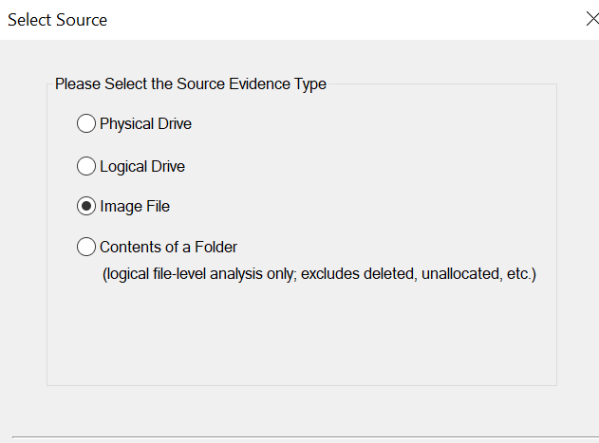 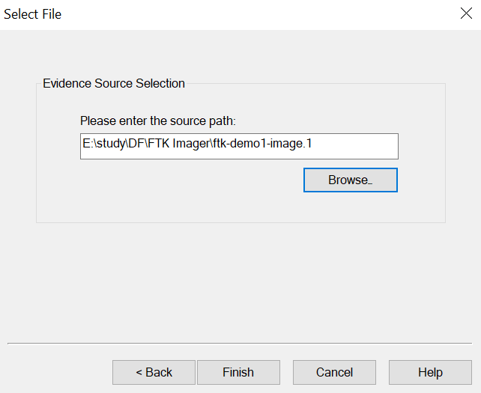

Successfully added Image file.

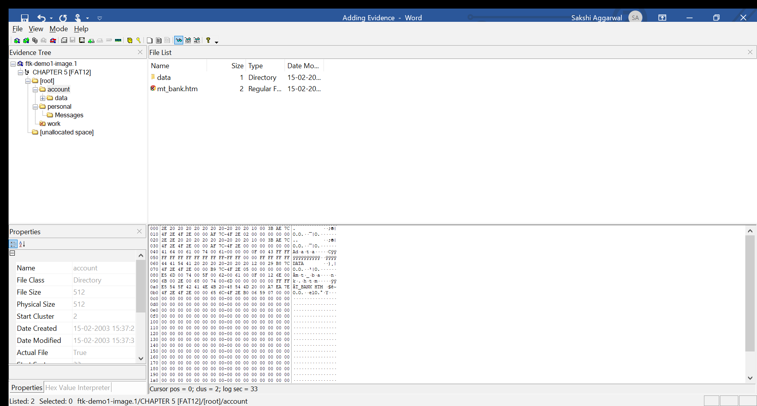

**Adding Contents of a folder**

Click on the ‘Contents of a Folder’ option to add a particular file or the folder. This option is used to analyse any file or folder of the suspect’s computer. Then browse for the path of the required file or folder. Add the source path and finish.

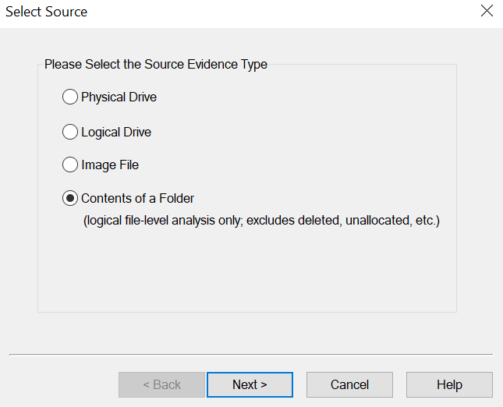 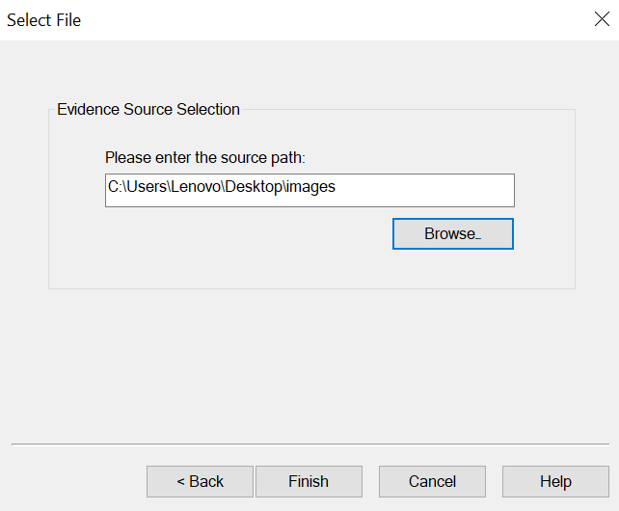

Successfully added the folder.

